GAN is about creating, like drawing a portrait or composing a symphony. This is hard compared to other deep learning fields. It is much easier to identify a Monet painting than painting one, by computers or by people. But it brings us closer in understanding intelligence. GAN leads us to thousands of GAN research papers written in recent years. In developing games, we hire many production artists to create animation. Some of the tasks are routine. By applying automation with GAN, we may one day focus ourselves to the creative sides rather than repeating routine tasks daily. Being a part of the [GAN series](https://medium.com/@jonathan_hui/gan-gan-series-2d279f906e7b), this article covers the GAN concept and its algorithm.

**What does GAN do?**

The main focus for GAN (Generative Adversarial Networks) is to generate data from scratch, mostly images but other domains including music have been done. But the [scope of application](https://medium.com/@jonathan_hui/gan-some-cool-applications-of-gans-4c9ecca35900) is far bigger than this. Just like the example below, it generates a zebra from a horse. In reinforcement learning, it helps a robot to learn much faster.



Right side image created by CycleGAN [Source](https://junyanz.github.io/CycleGAN/)

**Generator and discriminator**

GAN composes of two deep networks, the **generator,**and the **discriminator**. We will first look into how a generator creates images before learning how to train it.

First, we sample some noise ***z*** using a normal or uniform distribution. With ***z*** as an input, we use a generator ***G*** to create an image ***x****(x=G(z))*. Yes, it sounds magical and we will explain it one-step at a time.

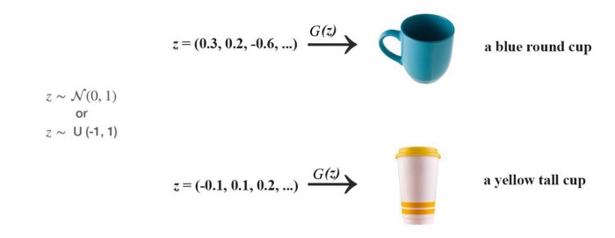

Conceptually, ***z*** represents the latent features of the images generated, for example, the color and the shape. In Deep learning classification, we don’t control the features the model is learning. Similarly, in GAN, we don’t control the semantic meaning of ***z***.We let the training process to learn it. i.e. we do not control which byte in *z* determines the color of the hair. To discover its meaning, the most effective way is to plot the generated images and examine ourselves. The following images are generated by progressive GAN using random noise *z!*

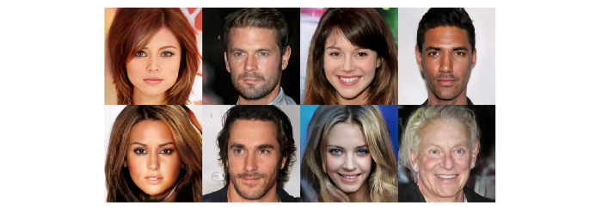

[Progressive growing of GANs](https://arxiv.org/pdf/1710.10196.pdf)

We can change one particular dimension in *z* gradually and visualize its semantic meaning.

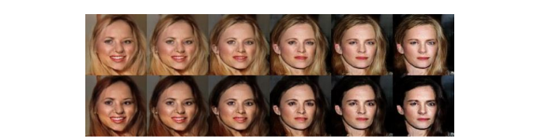

Images produced in [CoGAN](https://arxiv.org/pdf/1606.07536.pdf)

**So what is this magic generator *G*?** The following is the DCGAN which is one of the most popular designs for the generator network. It performs multiple transposed convolutions to upsample *z* to generate the image *x*. We can view it as the deep learning classifier in the reverse direction.

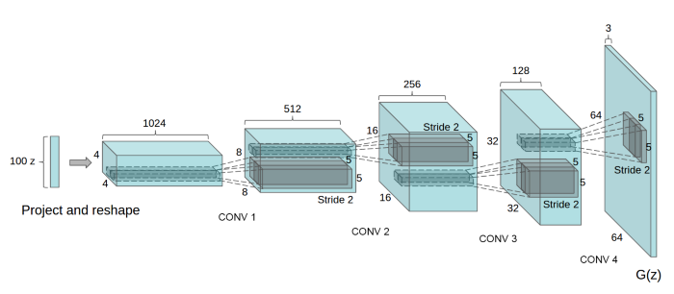

A generator in DCGAN. [Source](https://arxiv.org/pdf/1511.06434.pdf)

But a generator alone will just create random noise. Conceptually, the discriminator in GAN provides guidance to the generator on what images to create. Let’s consider a GAN’s application, CycleGAN, that uses a generator to convert real scenery into a Monet style painting.

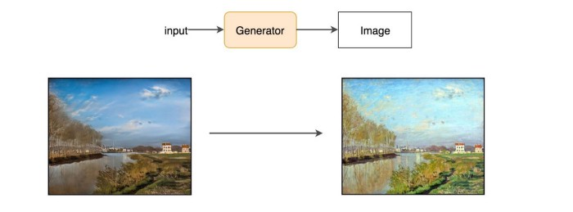

Modified form [CycleGAN](https://medium.com/@jonathan_hui/gan-cyclegan-6a50e7600d7)

By training with real images and generated images, GAN builds a discriminator to learn what features make images real. Then the same discriminator will provide feedback to the generator to create paintings that look like the real Monet paintings.

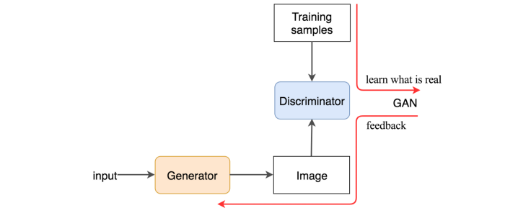

So how is it done technically? The discriminator looks at real images (training samples) and generated images separately. It distinguishes whether the input image to the discriminator is real or generated. The output *D(X)* is the probability that the input *x* is real, i.e. *P(class of input = real image).*

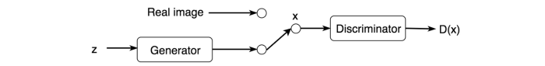

We train the discriminator just like a deep network classifier. If the input is real, we want *D(x)=1.*If it is generated, it should be zero. Through this process, the discriminator identifies features that contribute to real images.

On the other hand, we want the generator to create images with *D(x) = 1*(matching the real image). So we can train the generator by backpropagation this target value all the way back to the generator, i.e. we train the generator to create images that towards what the discriminator thinks it is real.

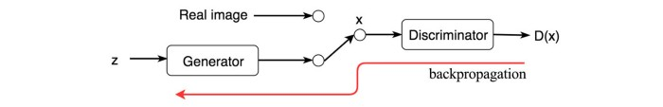

We train both networks in alternating steps and lock them into a fierce competition to improve themselves. Eventually, the discriminator identifies the tiny difference between the real and the generated, and the generator creates images that the discriminator cannot tell the difference. The GAN model eventually converges and produces natural look images.

This discriminator concept can be applied to many existing deep learning applications also. The discriminator in GAN acts as a critic. We can plug the discriminator into existing deep learning solutions to provide feedback to make it better.

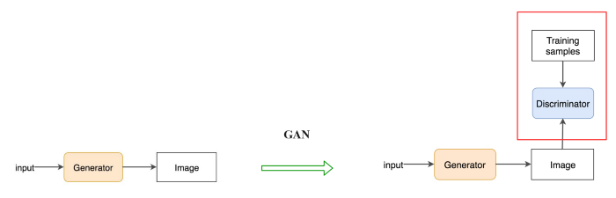

**Backpropagation**

Now, we will go through some simple equations. The discriminator outputs a value ***D(x)*** indicating the chance that *x* is a real image. Our objective is to maximize the chance to recognize real images as real and generated images as fake. i.e. the maximum likelihood of the observed data. To measure the loss, we use [cross-entropy](https://jhui.github.io/2017/01/05/Deep-learning-Information-theory/) as in most Deep Learning: *p log(q).*For real image, *p* (the true label for real images) equals to 1. For generated images, we reverse the label (i.e. one minus label*)*. So the objective becomes:

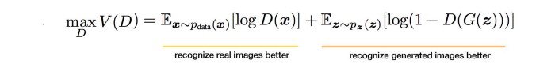

On the generator side, its objective function wants the model to generate images with the highest possible value of *D(x)* to fool the discriminator.

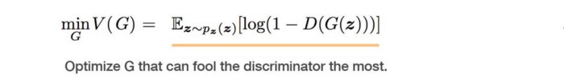

We often define GAN as a minimax game which ***G*** wants to minimize ***V***while ***D*** wants to maximize it.



Once both objective functions are defined, they are learned jointly by the alternating gradient descent. We fix the generator model’s parameters and perform a single iteration of gradient descent on the discriminator using the real and the generated images. Then we switch sides. Fix the discriminator and train the generator for another single iteration. We train both networks in alternating steps until the generator produces good quality images. The following summarizes the data flow and the gradients used for the backpropagation.

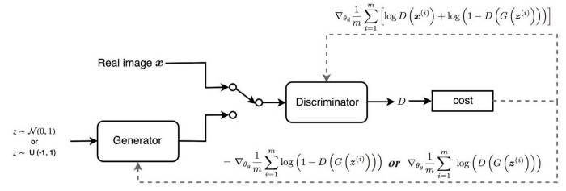

The pseudo code below puts everything together and shows how GAN is trained.

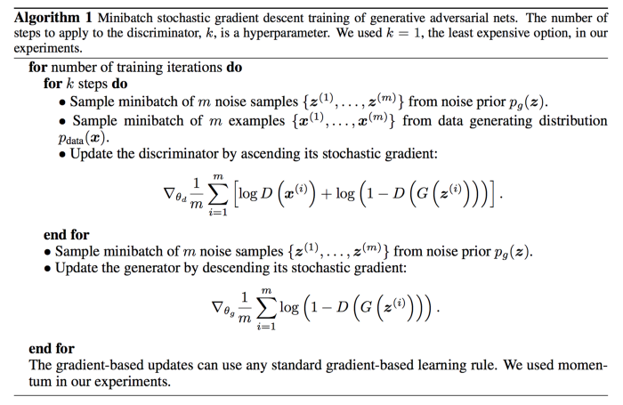

Usually with k=1 [Source](https://arxiv.org/pdf/1406.2661.pdf)

**Generator diminished gradient**

However, we encounter a gradient diminishing problem for the generator. The discriminator usually wins early against the generator. It is always easier to distinguish the generated images from real images in early training. That makes *V* approaches 0. i.e. - *log(1 -D(G(z)))****→****0*. The gradient for the generator will also vanish which makes the gradient descent optimization very slow. To improve that, the GAN provides an alternative function to backpropagate the gradient to the generator.



Cycle Gan:

Many GAN research focuses on model convergence and mode collapse. We deal with game theories that we do not know how to solve it efficiently. But GAN can be fun, in particular for cross-domain transfer. CycleGAN transfers styles to images. For example, we start with collecting three sets of pictures: one for real scenery, one for Monet paintings and the last one for Van Gogh. Can we take a real picture and transfer the style of Monet or Van Gogh onto it? On the other hand, can we make a Monet picture looks real?

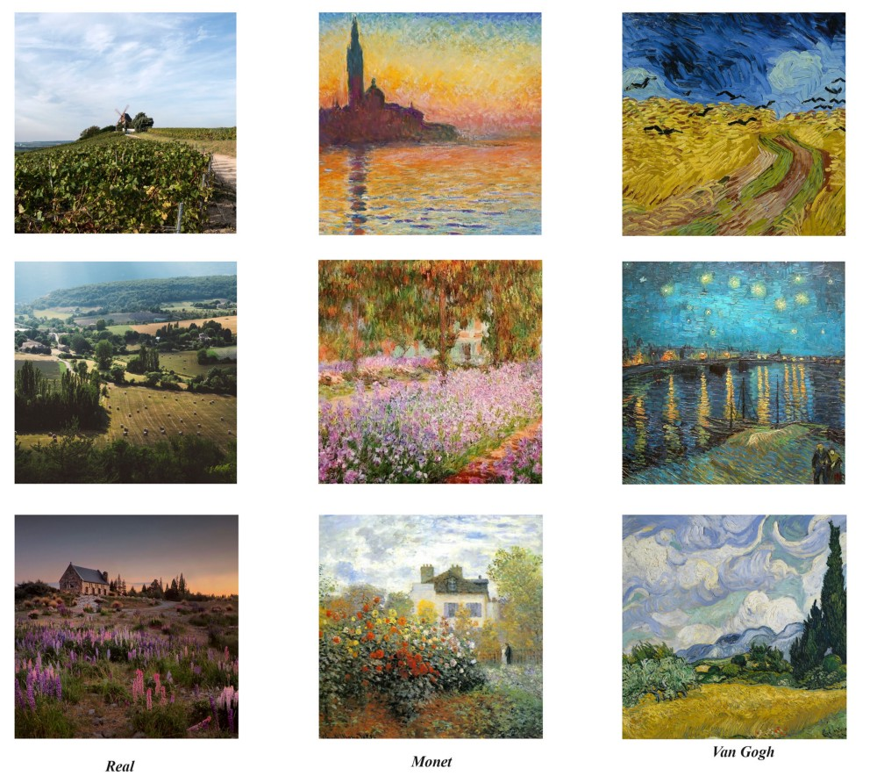

Can we turn a picture in the summer to winter?

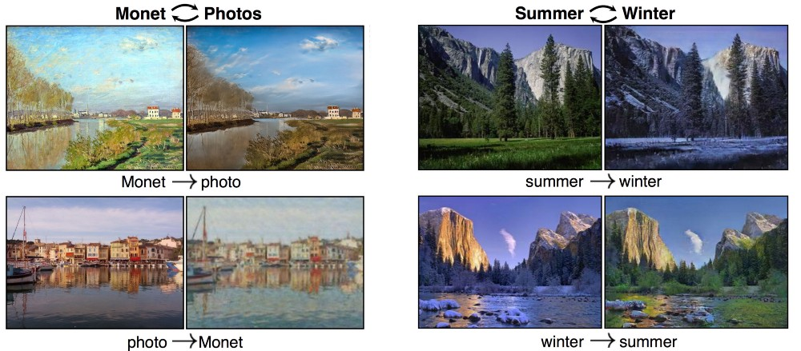

[Source](https://arxiv.org/pdf/1703.10593.pdf)

In addition, the set of images are not paired, i.e. we do not have the real images corresponding to the same locations where Monet painted the pictures. CycleGAN learns the style of his images as a whole and applies it to other types of images.

# CycleGAN

The concept of applying GAN to an existing design is very simple. We can treat the original problem as a simple image reconstruction. We use a deep network **G** to convert image **x** to **y**. We reverse the process with another deep network **F** to reconstruct the image. Then, we use a mean square error MSE to guide the training of **G** and **F**.

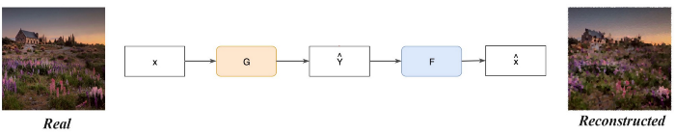

However, we are not interested in reconstructing images. We want to create **y** resembling certain styles. In GAN, a discriminator **D** is added to an existing design to guide the generator network to perform better. **D** acts as a critic between the training samples and the generated images. Through this criticism, we use backpropagation to modify the generator to produce images that address the shortcoming identified by the discriminator. In this problem, we introduce a discriminator D to make sure Y resemble Van Gogh paintings.

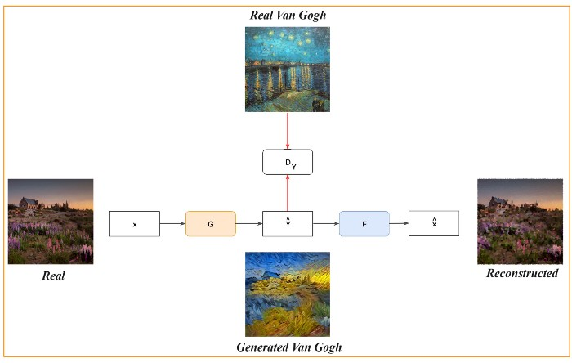

# ****Network design****

CycleGAN transfers pictures from one domain to another. To transform pictures between real images and Van Gogh paintings. We build three networks.

* A generator **G** to convert a real image to a Van Gogh style picture.
* A generator **F** to convert a Van Gogh style picture to a real image.
* A discriminator **D** to identify real or generated Van Gogh pictures.

For the reverse direction, we just reverse the data flow and build an additional discriminator **Dx** to identify real images.

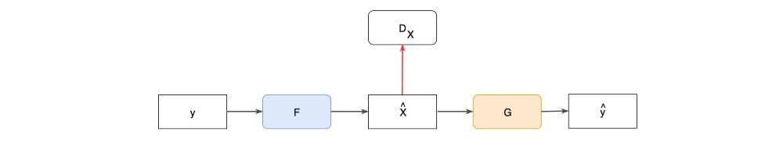

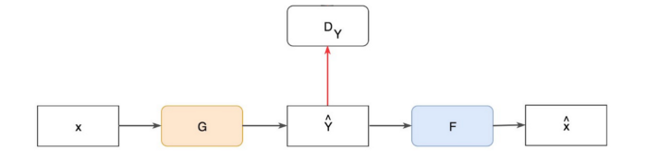

# ****Cost function****

Training GAN is like training a design without GAN and then put back the adversary loss for the generator and the discriminator.

We first determine the reconstruction cost

* This is the Cycle consistency loss which measures the L1-norm reconstruction cost for the real image (x → y → reconstructed x) and the Monet paintings (y → x → reconstructed y)



Then we add the adversary loss for the generator and the discriminator.

* Adversary loss

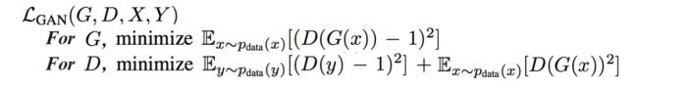

Here is the final objective function:



In addition, CycleGAN retains a history of the last 50 generated images to train the discriminator. Discriminators and generators can overfit themselves and fall into a cycle of greedy optimization that leads to the mode collapse. We use experience replay so the discriminator will not be overzealous in beating the current generator. It needs to beat the last 50 generators to create a more generalized solution.

# GAN — Ways to improve GAN performance

GAN models can suffer badly in the following areas comparing to other deep networks.

* [**Non-convergence**](https://medium.com/@jonathan_hui/gan-why-it-is-so-hard-to-train-generative-advisory-networks-819a86b3750b#e633): the models never converge and worse they become unstable.
* [**Mode collapse**](https://medium.com/@jonathan_hui/gan-why-it-is-so-hard-to-train-generative-advisory-networks-819a86b3750b#4987): the generator produces a single or limited modes, and
* **Slow training:**the gradient to train the generator vanished.

As part of the GAN series, this article looks into ways on how to improve GAN. In particular,

* Change the cost function for a better optimization goal.
* Add additional penalties to the cost function to enforce constraints.
* Avoid overconfidence and overfitting.
* Better ways of optimizing the model.
* Add labels.

**Feature Matching**

The generator tries to find the best image to fool the discriminator. The “best” image keeps changing when both networks counteract their opponent. However, the optimization can turn too greedy and fall it into a never-ending cat-and-mouse game. This is one of the [scenarios](https://medium.com/@jonathan_hui/gan-why-it-is-so-hard-to-train-generative-advisory-networks-819a86b3750b#1d4a) that the model does not converge and mode collapses.

Feature matching changes the cost function for the generator to minimizing the statistical difference between the features of the real images and the generated images. Often, we measure the L2-distance between the means of their feature vectors. Therefore, feature matching expands the goal from beating the opponent to matching features in real images. Here is the new objective function:



where*f(x)* is the feature vector extracted in an immediate layer by the discriminator.

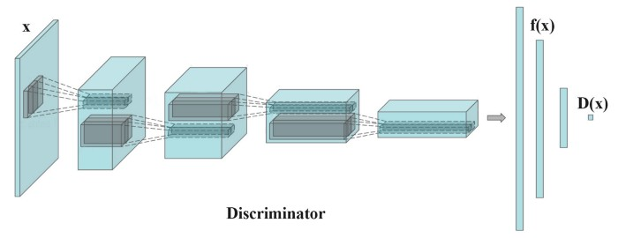

The means of the real image features are computed per minibatch which fluctuate on every batch. It is good news in mitigating the mode collapse. It introduces randomness that makes the discriminator harder to overfit itself.

*Feature matching is effective when the GAN model is unstable during training.*

**Minibatch discrimination**

When mode collapses, all images created looks similar. To mitigate the problem, we feed real images and generated images into the discriminator separately in different batches and compute the similarity of the image *x*with images in the same batch. We append the similarity ***o(x)***in one of the dense layers in the discriminator to classify whether this image is real or generated.





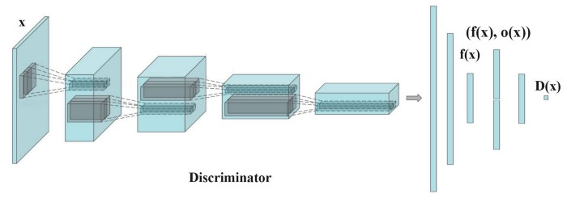

If the mode starts to collapse, the similarity of generated images increases. The discriminator can use this score to detect generated images and penalize the generator if mode is collapsing.

The similarity ***o(xi)*** between the image ***xi***and other images in the same batch is computed by a transformation matrix ***T***. The equations are a little bit hard to trace but the concept is pretty simple. But feel free to skip to next section if you want.

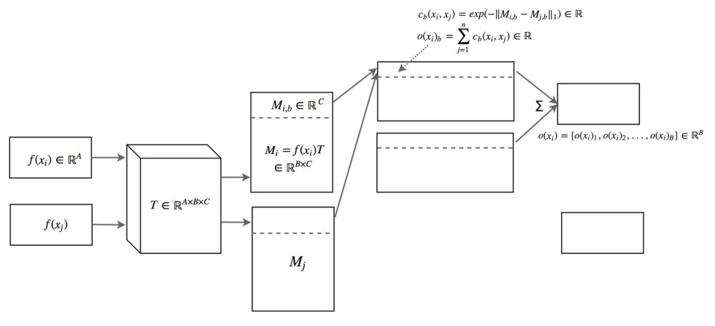

In the figure above, ***xi*** is the input image and ***xj*** is the rest of the images in the same batch. We use a transformation matrix ***T*** to transform the features ***xi*** to ***Mi***which is a B×C matrix.





We derive the similarity ***c(xi, xj)*** between image ***i*** and ***j*** using the L1-norm and the following equation.



The similarity ***o(xi)*** between image ***xi*** and the rest of images in the batch is

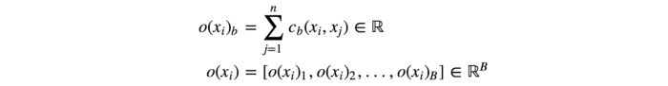

Here is the recap:

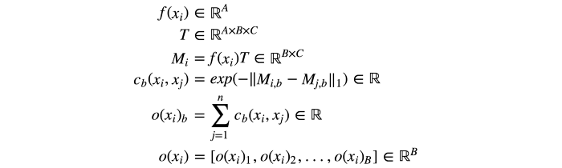

As a quote from the paper “Improved Techniques for Training GANs”

*Minibatch discrimination allows us to generate visually appealing samples very quickly, and in this regard it is superior to feature matching.*

***One-sided label smoothing***

Deep networks may suffer from overconfidence. For example, it uses very few features to classify an object. To mitigate the problem, deep learning uses regulation and dropout to avoid overconfidence.

In GAN, if the discriminator depends on a small set of features to detect real images, the generator may just produce these features only to exploit the discriminator. The optimization may turn too greedy and produces no long term benefit. In GAN, overconfidence hurts badly. To avoid the problem, we penalize the discriminator when the prediction for any real images go beyond 0.9 (*D(real image)>0.9*). This is done by setting our target label value to be 0.9 instead of 1.0. Here is the pseudo code:

p = tf.placeholder(tf.float32, shape=[None, 10])# Use 0.9 instead of 1.0.  
feed_dict = {  
 p: [[0, 0, 0, 0.9, 0, 0, 0, 0, 0, 0]] # Image with label "3"  
}# logits_real_image is the logits calculated by   
# the discriminator for real images.  
d_real_loss = tf.nn.sigmoid_cross_entropy_with_logits(  
 labels=p, logits=logits_real_image)

**Historical averaging**

In historical averaging, we keep track of the model parameters for the last ***t***models. Alternatively, we update a running average of the model parameters if we need to keep a long sequence of models.

We add an L2 cost below to the cost function to penalize model different from the historical average.



For GANs with non-convex object function, historical averaging may stop models circle around the equilibrium point and act as a damping force to converge the model.

***Experience replay***

The model optimization can be too greedy in defeating what the generator is currently generating. To address this problem, experience replay maintains the most recent generated images from the past optimization iterations. Instead of fitting the models with current generated images only, we feed the discriminator with all recent generated images also. Hence, the discriminator will not be overfitted for a particular time instance of the generator.

**Using labels (CGAN)**

Many datasets come with labels for the object type of their samples. Training GAN is already hard. So any extra help in guiding the GAN training can improve the performance a lot. Adding the label as part of the latent space ***z*** helps the GAN training. Below is the data flow used in [CGAN](https://medium.com/@jonathan_hui/gan-cgan-infogan-using-labels-to-improve-gan-8ba4de5f9c3d) to take advantage of the labels in the samples.

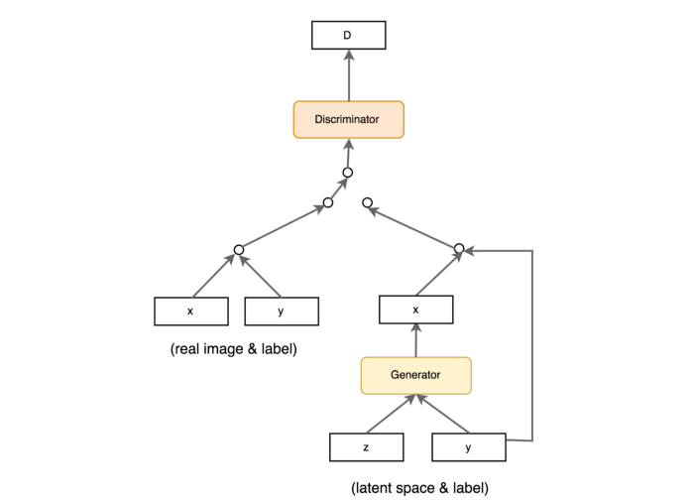

**Cost functions**

Do cost functions matter? It must be otherwise all those research efforts will be a waste. But if you hear about a 2017 Google Brain paper, you will definitely have doubts. But pushing image quality is still a top priority. Likely, we will see researchers trying different cost functions before we have a definite answer for the merit.

The following figure lists the cost functions for some common GAN models.

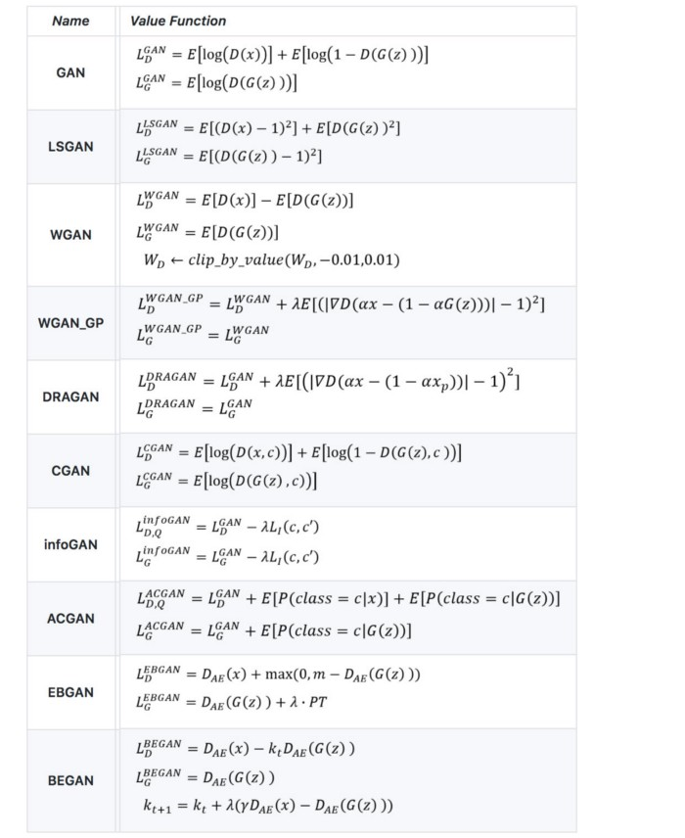

Table modified from [here](https://github.com/hwalsuklee/tensorflow-generative-model-collections).

We decide not to detail these cost functions in this article. Here are the articles that covers some common cost functions in details: [WGAN/WGAN-GP](https://medium.com/@jonathan_hui/gan-wasserstein-gan-wgan-gp-6a1a2aa1b490), [EBGAN/BEGAN](https://medium.com/@jonathan_hui/gan-energy-based-gan-ebgan-boundary-equilibrium-gan-began-4662cceb7824), [LSGAN](https://medium.com/@jonathan_hui/gan-lsgan-how-to-be-a-good-helper-62ff52dd3578), [RGAN and RaGAN](https://medium.com/@jonathan_hui/gan-rsgan-ragan-a-new-generation-of-cost-function-84c5374d3c6e). At the end of this article, we list an article that studies all these cost functions in more details. Since cost function is one major research area in GAN, we do encourage you to read that article later.

Here is some of the FID score (the lower the better) on some of the datasets. This is one reference point but be warned that it is still too early to make any conclusion on what cost functions perform the best. Indeed, there is no single cost function performs the best among all different datasets yet.

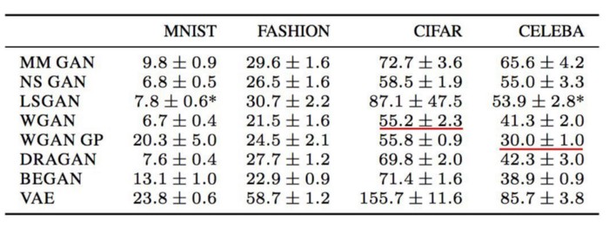

[Source](https://arxiv.org/pdf/1711.10337.pdf)

(MM GAN is the GAN cost functions in the original paper. NS GAN is the alternative cost functions addressing the vanishing gradients in the same paper.)

But no model performs well without good hyperparameters and tuning GANs takes time. Be patient in the hyperparameters optimization before randomly testing different cost functions.

**Implementation tips**

* Scale the image pixel value between -1 and 1. Use tanh as the output layer for the generator.
* Experiment sampling ***z*** with gaussian distributions.
* Batch normalization often stabilizes training.
* Use PixelShuffle and transpose convolution for upsampling.
* Avoid max pooling for downsampling. Use convolution stride.
* Adam optimizer usually works better than other methods.
* Add noise to the real and generated images before feeding them into the discriminator.

The dynamics of the GAN models are not well understood yet. So some of the tips are just suggestions and the mileage may vary. For example, the LSGAN paper reports RMSProp has more stable training in their experiments. This is kind of rare but demonstrates the challenges of making generic recommendations.

**Virtual batch normalization (VBN)**

Batch normalization BM becomes a de facto standard in many deep network design. The mean and the variance of BM is derived from the current minibatch. However, it creates a dependency between samples. The generated images are not independent of each other.





This is reflected in experiments which generated images show color tint in the same batch.

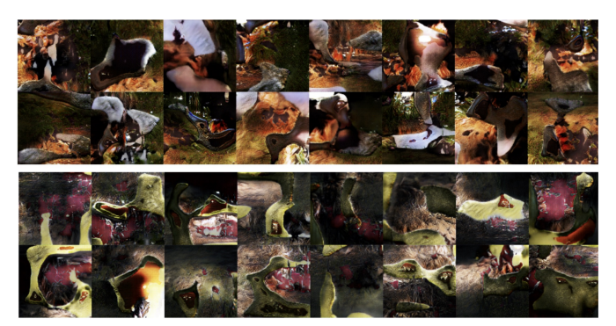

Orange tone on the top batch and greenish tone on the second. [Source](https://arxiv.org/pdf/1701.00160v3.pdf)

Originally, we sample ***z*** from a random distribution that gives us independent samples. However, the bias created by the batch normalization overwhelm the randomness of ***z***.

Virtual batch normalization (VBN) samples a reference batch before the training. In the forward pass, we can preselect a reference batch to compute the normalization parameters (*μ* and σ) for the BN. However, we will overfit the model with this reference batch since we use the same batch over the whole training. To mitigate that, we can combine a reference batch with the current batch to compute the normalization parameters.

**Random seeds**

The random seeds used to initialize the model parameters impact the performance of GAN. As shown below, the FID scores in measuring the GAN performance vary in 50 individual runs (training). But the range is relatively small and likely to be done in later fine tuning only.

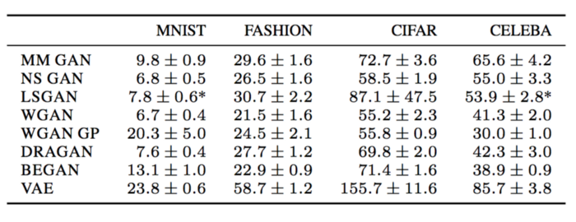

[Source](https://arxiv.org/pdf/1711.10337.pdf)

A Google Brain paper indicates LSGAN occasionally fails or collapses in some dataset, and training needs to be restarted with another random seed.

**Batch normalization**

DGCAN strongly recommends adding BM into the network design. The use of BM also become a general practice in many deep network model. However, there will be exceptions. The following figure demonstrates the impact of BN on different dataset. The y-axis is the FID score which the lower the better. As suggested by the WGAN-GP paper, BN should be off when it is used. We suggest readers to check the cost function used and the corresponding FID performance on BN, and verify the setting with experiments.

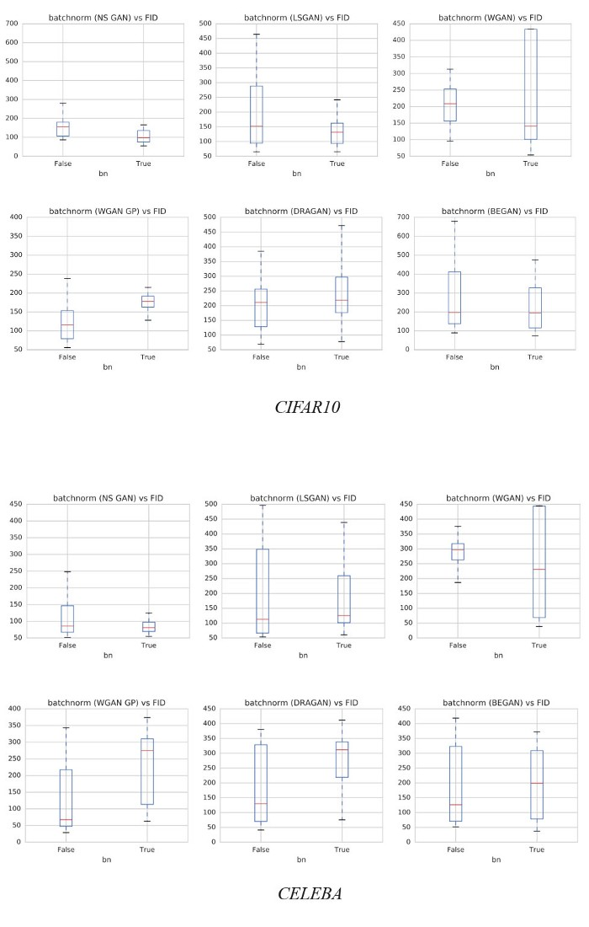

Modified from [source](https://arxiv.org/pdf/1711.10337.pdf).

**Multiple GANs**

Mode collapse may not be all bad. The image quality often improves when mode collapses. In fact, we may collect the best model for each mode and use them to recreate different modes of images.

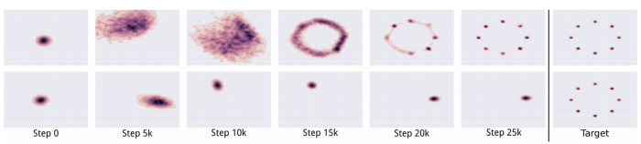

[Source](https://arxiv.org/pdf/1611.02163.pdf)

**Balance between discriminator & generator**

The discriminator and generator are always in a tug of war to undercut each other. Mode collapse and gradient diminishing are often explained as an imbalance between the discriminator and the generator. We can improve GAN by turning our attention in balancing the loss between the generator and the discriminator. Unfortunately, the solution seems elusive. We can maintain a static ratio between the number of the gradient descent iterations on the discriminator and the generator. Even this seems appealing but many doubt its benefit. Often, we maintain a one-to-one ratio. But some researchers also test out a ratio of 5 discriminator iterations per generator update. Balancing both networks with dynamic mechanics is also proposed. But not until recent years, we get some traction on it.

On the other hand, some researchers challenge the feasibility and desirability of balancing these networks. A well-trained discriminator gives quality feedback to the generator anyway. Also, it is not easy to train the generator to always catch up with the discriminator. Instead, we may turn the attention into finding a cost function that does not have a close-to-zero gradient when the generator is not performing well.



Nevertheless, issues remain. Many cost function proposals are made and the debates on what is the best remain.

**Discriminator & generator network capacity**

The model for the discriminator is usually more complex than the generator (more filters and more layers) and a good discriminator gives quality information. In many GAN applications, we may run into bottlenecks where increasing generator capacity shows no quality improvement. Until we identify the bottlenecks and resolve them, increasing generator capacity does not seem to be a priority for many partitioners.

# pggan-pytorch

A PyTorch simplified implementation of [Progressive Growing of GANs for Improved Quality, Stability, and Variation](https://arxiv.org/abs/1710.10196).

It's based on the reference implementation in Theano: <https://github.com/tkarras/progressive_growing_of_gans> and a few other implementations named in acknowledgements below. It's more modularized and specifically designed for training the Progressively Growing GAN networks with WGAN-GP loss. Main focus for this implementation in terms of domain of generation were spectrograms and other visual representations of audio and thus it contains a few helpers for these tasks (but also works for any other kind of image). For more details on results in audio generation, see our blog post: <http://deepsound.io/samplernn_pytorch.html>.

The model and implementation proved itself to be succesful - and as for now, the authors are not aware of any other succesful GAN application to audio signal generation.

## Dependencies

This code requires Python 3.5+ and was tested under PyTorch 0.2.0+. Other dependencies depend on the usage, most important for sound generation being Librosa 0.4.3+ and SoundFile 0.9.0+ (latter for efficient sound loading) and Pillow 4.0.0+ with scipy 0.19.0+ (possibly also works with earlier versions, these are the ones tested). Lastly, if you wish to use datasets created with original implementation's tool, you will need h5py 2.5.0+. Installation instructions for PyTorch are available on their website: <http://pytorch.org/>. You can install the rest of the dependencies for sound and image generation by running pip install -r requirements.txt.

## Datasets

Training on new data is as simple as implementing your own DepthDataset (see dataset.py) with all required methods. A few useful Datasets were already implemented:

* OldH5Dataset - allows use of (fitting in memory!) datasets from original implementation
* DefaultImageFolderDataset - takes any folder with images and creates a proper dataset
* SoundImageDataset - takes any folder with .wav files of length at least (n_fft*hop_length/2 + n_fft) (where n_fft and hop_length are desired parameters of stft). For example, a good start is to use 16000 hz, 5 second audio created by script from our [SampleRNN PyTorch implementation](https://github.com/deepsound/samplernn-pytorch/). This class can be a dataset of either magnitude spectrograms, "raw" data or real-part stfts, with best results obtained with magnitude spectrograms.

## Training

To train the model you need to run train.py. All model and training hyperparameters are settable in the command line in a very generic way - you can essentially pass ClassName.init_param_name for every class that will be instantiated during the training process. Sometimes you need to specify which classes you may want to instantiate, e.g. which kind of dataset or which output postprocessors. Most hyperparameters have sensible default values, so you don't need to provide all of them. Run python train.py -h for details. With piano dataset from our script mentioned before, you can run:

python train.py --exp_name TEST \

--dataset_class SoundImageDataset --SoundImageDataset.dir_path PATH_TO_DATASET_FOLDER \

--SoundImageDataset.preload True --SoundImageDataset.img_mode abslog \

--postprocessors ['ImageSaver', 'SoundSaver'] \

--ImageSaver.samples_path images --SoundSaver.samples_path sound

If you would like to keep lod information from original implementation in logging, add --DepthManager.max_lod and --DepthManager.depth_offset parameters.

The results - training log, model checkpoints and postprocessed generated samples will be saved in results_dir/NUMEXP-exp_name/. NUMEXP is number one greater than maximal number of experiments in results directory.

We also have an option to monitor the metrics using [CometML](https://www.comet.ml/). To use it, just pass your API key as --comet_key parameter to train.py. For newer versions of CometML, you may also pass sensible --comet_project_name.

## Main differences compared to original implementation

Main difference is substitution of LOD parameter in exchange for two, more related to the paper parameters: depth and alpha. The inspiration for this is also the Chainer implementation (see acknowledgements). Also, this implementation is completely agnostic of a term of resolution and everything can be specified just by proper depth, max_depth and depth_offset parameters. In this implementation, parameter DepthManager.max_lod corresponds to log2(resolution) and model_dataset_depth_offset (in the selected dataset) corresponds to log2(initial_resolution). This is motivated by the following logic: neural models should always have their parameter depth corresponding to the index of deepest layer trainable, while datasets can also provide versions of data for other depths (it works this way also in original implementation, where dataset always creates inputs downsampled down to 2^0 x 2^0). If you provide --DepthManager.max_lod and --DepthManager.depth_offset parameters, you can have old-style lod displayed in lod, equal to max_lod - depth_offset - depth + 1 - alpha.

There is a lot of unimplemented features of the original paper, such as conditional training, a few network parameters etc. which we didn't find useful (for now!) during spectrogram generation which is main purpose of this implementation. All the default parameters for generating the 1024x1024 faces from the original paper are implemented.

The training process in Trainer class resembles the original implementation notion of "nimg", "kimg" and "ticks" instead of "iterations" or "epochs". For the ease of use of several built-in plugins and to satisfy both PyTorch and the original implementation, "tick" is equivalent to "epoch".

Take note, that with simple proper initializations of depth / plugin parameters, you can train your own progressively growing networks, which only need to specify their max_depth and make use of depth and alpha parameters. Or, you may wish to train regular (non-progressive) GANs with this framework - for ease of use, you just need to turn pass --progressive_growing False param.

## Acknowledgments

Original implementation: <https://github.com/tkarras/progressive_growing_of_gans> Few other inspirations:

* chainer-PGGAN: <https://github.com/joisino/chainer-PGGAN>
* PyTorch - progressive growing of gans: <https://github.com/github-pengge/PyTorch-progressive_growing_of_gans>
* wgan-gp pytorch - <https://github.com/caogang/wgan-gp>

We want to highlight, that these were strong, but still just an inspiration for rewriting the code from scratch, even though a clear resemblence of the code from mentioned implementation can be seen.

## Final remarks

The code is in constant development. :) We publish it now, because you can always improve something. It is possible, that much more detailed implementations may arise for both PGGAN-general framework and Signal-Generating Progressively Growing GANs (SGPGGAN acronym isn't hopefully taken yet).